Minister for Environment Hon. Andrew Powell
Phone: (07) 3719 7300
Email: environment@ministerial.qld.gov.au
Ministerial Office 1 William Street
BRISBANE QLD 4000

The Hon. Andrew Powell
Queensland Minister for Environment
Subject: Objection to the shooting of flying-foxes and support for humane alternatives

Dear Minister,
I am writing as a concerned member of the public to express strong opposition to the continued shooting of flying-foxes for fruit crop protection in Queensland.

It is understood that the Queensland Government has committed to ending shooting permits by July 2026. However, there is significant concern that shooting continues in the interim, despite well‑documented animal welfare, conservation, and ecological impacts.

When flying-foxes are shot, many do not die immediately. Injuries such as fractured wing bones often result in prolonged suffering and an inability to fly, leading to slow deaths from starvation, dehydration, or predation.
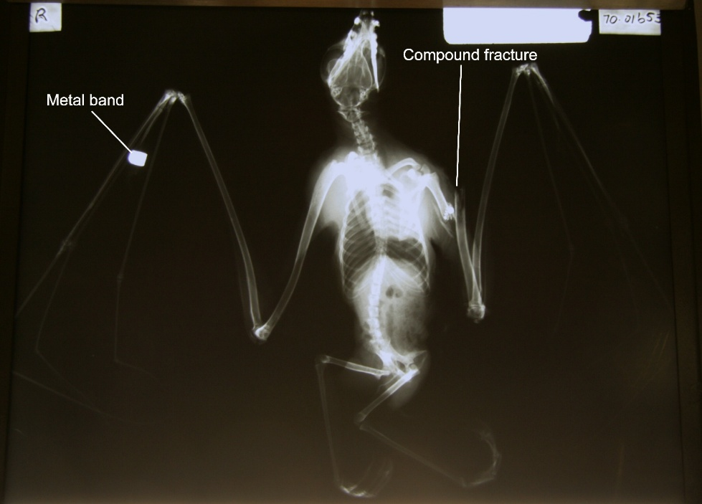
Flying-foxes give birth to only one pup per year. Shooting a pregnant flying-fox results in the death of both mother and pup. Shooting a lactating mother leaves her dependent pup stranded in a camp creche, where it will die slowly from starvation as it relies entirely on its mother’s milk.
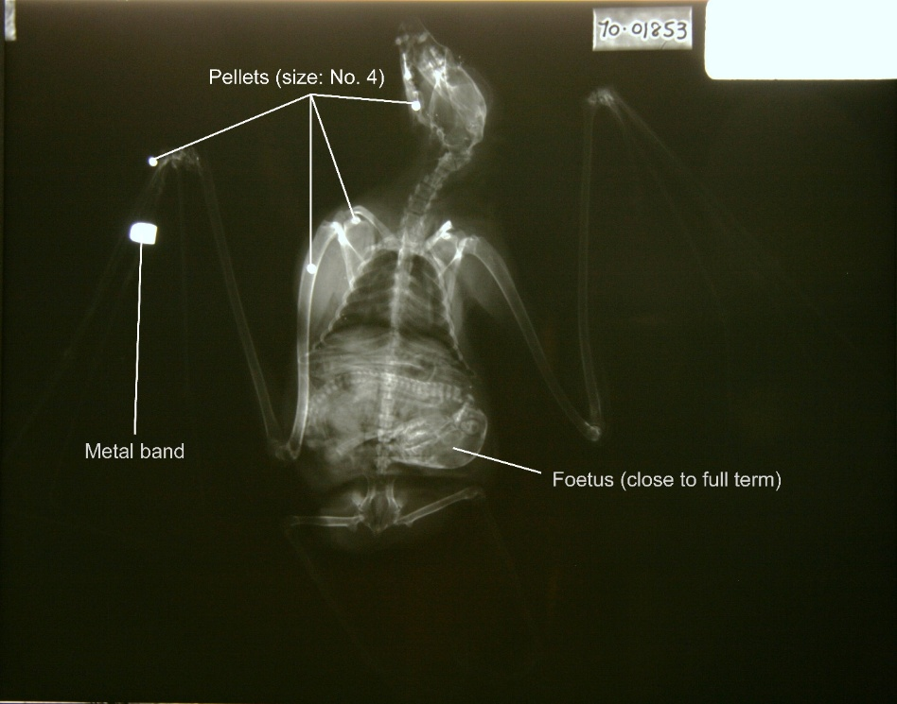
There is a proven, humane alternative. Exclusion netting is the most reliable and effective method of protecting fruit crops from flying-foxes and other wildlife. In New South Wales, the Flying‑fox Netting Subsidy Program successfully assisted growers with the cost of installing wildlife‑safe exclusion netting and was implemented alongside the phase‑out of legal shooting. This approach reduced conflict, protected livelihoods, and avoided unnecessary animal suffering.

Grey‑headed flying‑foxes are listed as a threatened species at the national level. Allowing the shooting of a threatened species is unacceptable and inconsistent with conservation objectives. Flying‑foxes are also vital to Australia’s ecosystems, acting as key pollinators and seed dispersers for forests and woodlands.

Populations are already under severe pressure from habitat loss and climate change, with extreme heat events causing mass mortality. Continued shooting further contributes to population decline and undermines recovery efforts for a species already listed as vulnerable.

I urge the Queensland Government to end shooting permits for flying‑foxes as a matter of priority and to implement a netting subsidy program similar to that successfully used in New South Wales.

Thank you for considering this submission.
Yours sincerely,

