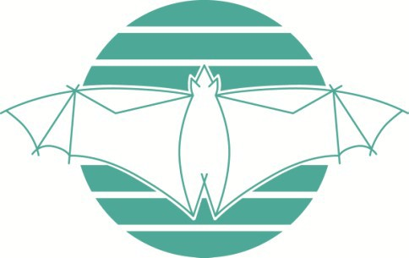
Ku-ring-gai Bat Conservation Society Inc.

MEMBERSHIP APPLICATION

Membership is available in three categories. Each category carries a single voting right. Please underline the category for which you are applying:

Individual Family/household Organisation

Title | First name |  | Last name
Name of organisation (if applicable)
Address
Phone |  | Email

Updates covering KBCS activities are emailed to our members quarterly.
Annual membership fee - individual, household or organisation
within Australia: AU$20.00
overseas: AU$25.00
(Membership is due and payable 1st July each year - you will receive a reminder)
Donation (Donations are always welcome. Donations over $2 are tax deductible in Australia. A receipt will be mailed or emailed to you.)
Total Payment | $

Payment Method

Please note: If you would like to include a donation, please deposit your payment in our Gift Fund Account specified below, otherwise you can use our Operating Account

Direct Deposit
Westpac BSB: 032083
Account No:
for membership only (Operating Account): 207854
for membership + donation (Gift Fund): 207862
Please tag the payment with your name and email a completed form to web@sydneybats.org.au
Cheque/Money order
Mail completed form & payment to:
Treasurer,
KBCS Inc.
PO Box 607
GORDON NSW 2072
Australia

